MEDIEVAL MANOR
by Lloyd Krassner

Original rules can be found on the Warspawn Games website-
http://www.angelfire.com/games2/warpspawn/MedMan.html
This edition edited and playing pieces made by Peter Cobcroft
Contributer Credits
Card art from-
- Manners, Customs, and Dress During the Middle Ages, and During the Renaissance Period. By Paul Lacroix (http://www.gutenberg.org/files/10940/10940-h/10940-h.htm )
- Medieval Woodcuts Clipart Collection (http://www.godecookery.com/clipart/clart.htm)

Land art from-
- ACTmapI (http://www.actmapi.act.gov.au/)
- Google Maps (http://maps.google.com/) - primarily Sussex.

Peasant counter images courtesy of-
- Jeffery Bowling (http://www.boardgamegeek.com/user/hrc333∞)
- David Tolin (http://www.boardgamegeek.com/user/DavidT∞)
- Thierry Camprubi (http://www.boardgamegeek.com/user/tcamprubi∞)

INTRODUCTION
Number of Players: 2-4+ players.
Players are the inhabitants of a small European fiefdom during the middle ages. Players use their Peasants to gather goods and score Victory Points.

VICTORY
The game is over at the end of the turn in which any player has 25 or more Victory Points (VP).
- The winner is the player with the highest total VPs at the end of the game.
- If tied at the end, the player with the most Upgrades wins.
- If still tied, the player with the most Gold wins.

THE DECKS
There are 2 common decks:
The Land Deck (17 tiles including the Lord of the Manor tile) and the Play Deck (101 cards).

THE MAP
Use the tiles from the Land Deck to make a map.
As part of the map, these cards are also referred to as spaces.
- For a 2-3 player game use the 12 Basic lands (denoted with a “B” in the bottom right corner) to make a 3x4 grid.
  - The Basic Lands:
River, Fertile Fields, Good Fields, Poor Fields, Woods, Pasture, Hills, Road, Village, Market, Church, Castle
- For 4+ players also use the Extra lands (denoted with an “E” in the bottom right corner) to make a 4x4 grid.
  - The Extra Lands:
Irrigated Fields, Hunting Grounds, Mountains, Forest.

The Road and River must be placed on a Map edge.
For purposes of playing a Bounty or Upgrade card in the Work Phase, treat the Irrigated Fields as Fields, the Mountains as Hills, and the Forest and Hunting Grounds as Woods.

THE PLAY DECK
There are 3 types of cards:
Bounty cards, Upgrade cards, and Hardship cards.
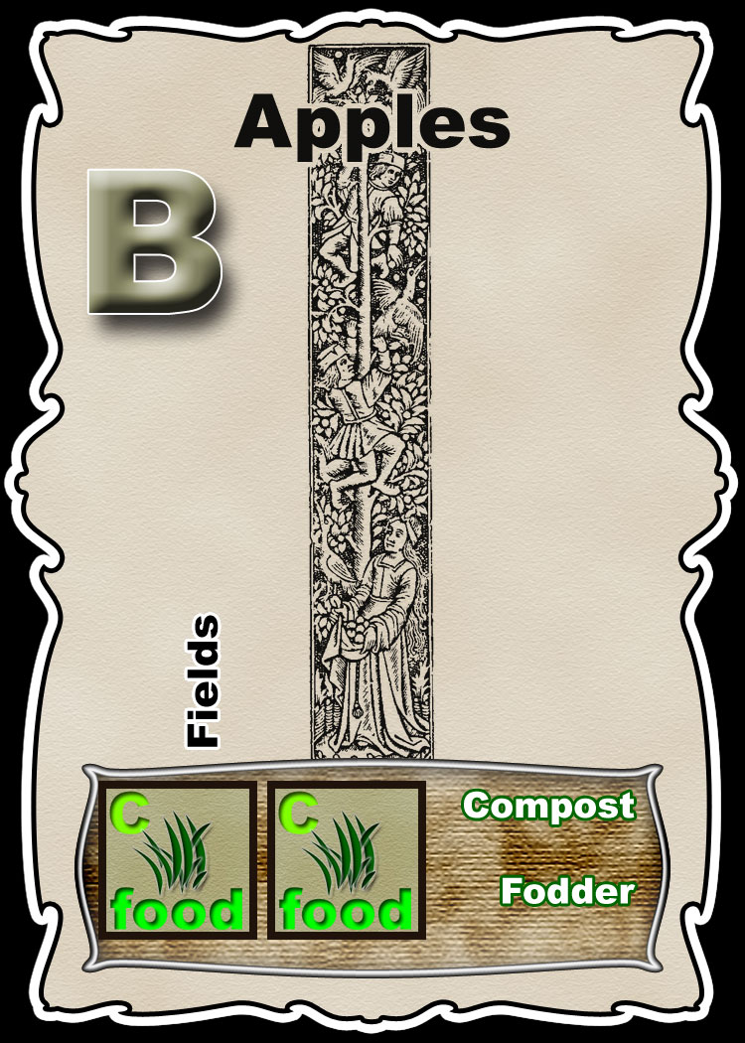
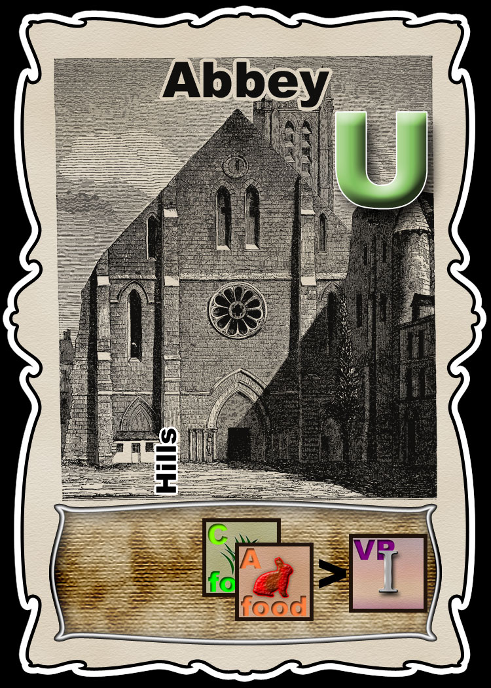
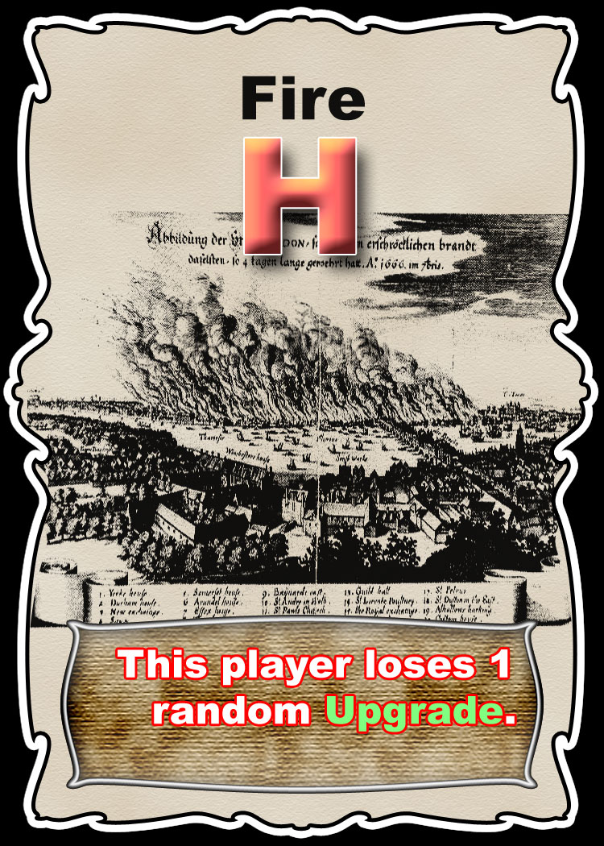

COUNTERS
There are 6 Types of Counter:

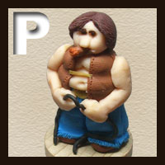 |  |  | 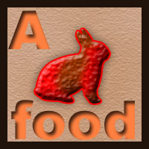 |  | 
Peasants (P) | Victory (VP) | Crops (C) | Animals (A) | Gold (G) | Resources (R)
 |  | Food  (Crops or Animals) |  | Money  (Gold or Resources)
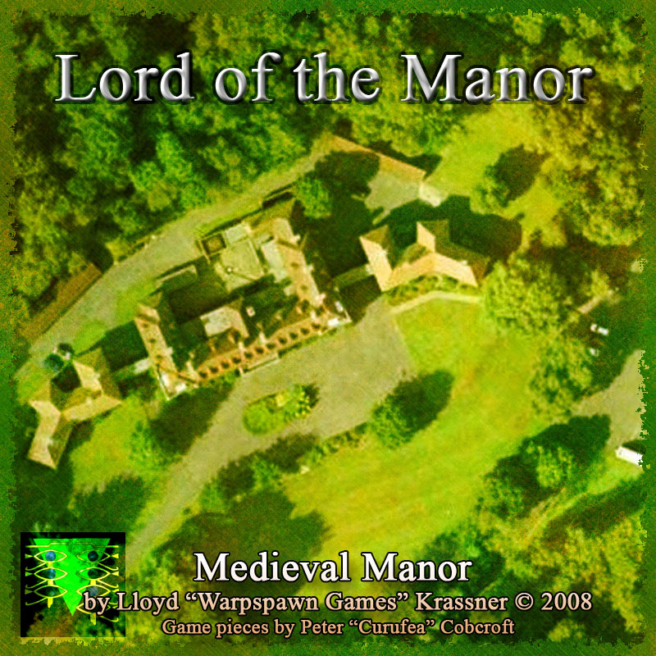 |  | Goods  (Crops, Animals, Gold or Resources)
Manor = a Land tile place in front of the current Lord.

SETUP
- Shuffle the Play Deck.
- Each player starts with 2 Peasants and 4 Crops.
- Deal each player 3 random cards. Any Hardship cards should be discarded and re-dealt.
- Pick one player to be the starting Lord of the Manor and give them the appropriate tile to mark them as the first player.

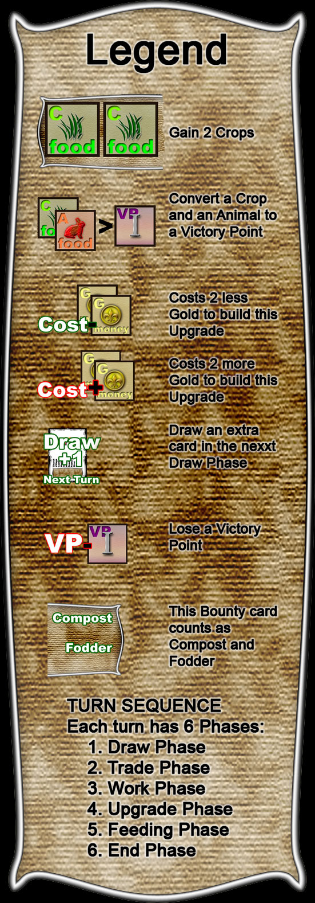
TURN SEQUENCE
Each turn has 7 Phases. Each player, starting with the Lord of the Manor and proceeding clockwise, participates in a phase.
    - Draw Phase
If the Play Deck ever runs out of cards, shuffle the discards and use them.
All cards are dealt face-up.
  - Each player is dealt as many cards from the Play Deck as they have Peasants.
  - Players may pay 3 goods to draw 3 more cards from the Play Deck. They must discard 2 of these cards. They may discard Hardship cards. This is the only circumstance in which a Hardship card may ever be discarded.
  - Players may discard 2 cards (that are not Hardship cards) and draw 1 replacement card.
- Trade Phase
  - There is no set order for trading, anyone may trade at any time in this phase.
  - Players always keep their hands face-up and visible to all.
  - Players may inspect each others hands.
  - Players may freely make deals and trade counters and cards with each other.
- Work Phase
Each player gets a number of actions equal to the number of Peasants they control.
Players take turns using one action at a time starting with the lord of the Manor and going clockwise.
Either of the following may be performed as an action
  - Take one of your hand cards (either a Bounty or an Upgrade) and place it on the map on a Land tile allowed by the card text.
You cannot place a card in a space that is already occupied by a card.
  - Discard 2 cards from your hand to gain 1 Good of any type.
- Rest Phase
  - All Bounty cards on the map are discarded.
  - All Upgrade cards on the map are placed in front of their owning player.

- Upgrade Phase
Each of your Upgrade cards in play produces a counter (or card) and may also be used to make a conversion according to its text.
For Example:
The Cathedral Upgrade would give you 1 Victory Point counter.

The Mine Upgrade would give you a simple gain of 1 Gold counter and would allow you to (multiple times if you want to and can) discard 1 card from your hand to gain 1 Gold counter.
When gaining a card as a result of a conversion, draw the top card of the deck and add it to your hand.
Note: The simple gain of an upgrade is automatic and occurs only once per turn, whereas conversions are optional and can be done multiple times.
- Feeding Phase
  - Discard one Food counter for each Peasant you control.
  - If you cannot feed all your peasants fully, discard one of them and lose 2 VT.
You cannot lose your last remaining Peasant.
  - If all of your Peasants are fed, you may discard 5 Food counters to gain 1 Peasant counter.
- End Phase
  - Max hand size is 3 cards unless you have Upgrades in play that increase your hand size.
  - Discard excess cards.

Cards
HARDSHIP CARDS (10)

Hardship cards take effect immediately in Draw Phase as soon as they are dealt (except when discarded as a result of paying 3 goods in 1.2) and are then discarded.

BOUNTY CARDS (59)

As soon as you play a Bounty card in the Work Phase you reap its benefits:
- Gains (bottom left side of card)
  - Gain the counters shown on the card.
  - Certain spaces will provide additional counters if you are gaining counters of the same type.
For example:
The Wheat card gives you 4 Crops.
If the wheat card was placed on a Fertile Field (+1C), you would gain a total of 5 Crops.
If placed on a Poor Field (-1C) you would get 3 Crops.
  - Compost, Cultivator, Fodder, Manure and Pollination
    - If your played card would give you one or more Crop counters and you place it orthogonally next to a Compost, Cultivar, Manure or Pollination card you gain an additional Crop counter.
    - If your played card would give you one or more Animal counters and you place it orthogonally next to a Fodder card you gain an additional Animal counter.
    - These bonuses are not retroactive.
- Conversions (bottom right side of card)
  - Some Bounty cards allow you to do a conversion where you may turn any number of certain kinds of counter into another type of counter.
  - This conversion can only be done when the card is played in the Work Phase.
  - Any time a card is played on the Castle, that player becomes the new Lord of the Manor. If no card is played on the Castle in the Work Phase, the current Lord remains.

Played Bounty cards are discarded in the Rest Phase.

UPGRADE CARDS (32)
- To play an Upgrade card you must pay 3+X Money counters.
X = The number of Upgrade cards you already own.
- In the Rest Phase remove Upgrade cards you just purchased and played to the map from the board and place them face-up next to you in their own separate section where they remain in play.
- Upgrade cards provide a bonus every turn they are in play in the Upgrade Phase. This may be a Gain, Conversion (see Bounty cards above), or some other special ability written in text on the card.
  - Conversions with Upgrade cards only occur in the Upgrade Phase. Like Bounty cards, you may convert as many things as you are able to supply the requirements necessary.

