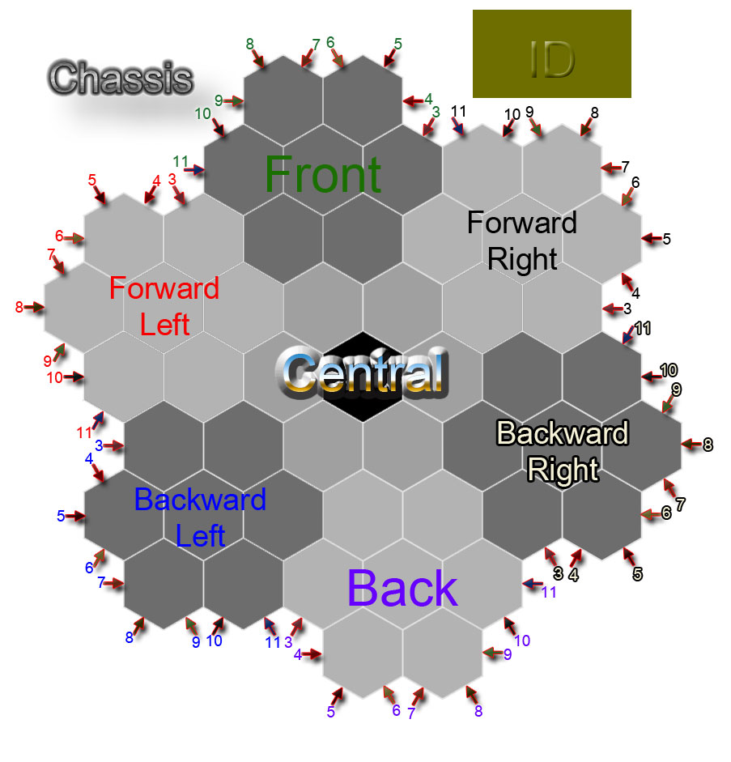
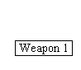
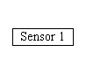

Armour Protection | Mobility  Speed | Sensor  Range | Connector
Armour  Resistance | Mobility  Terrain | Weapon  Damage
Boiler | Sensor  Accuracy | Weapon  Range

